**INTERNATIONAL INSTITUTE OF PROFFESIONAL STUDIES**

**Devi Ahilya Vishwavidyalaya**

**Indore, M.P**

Session: July-Dec, 2020

A

Project Report on

COVID-19 Vaccine Digital Distribution Proposal

Submitted By:

Deepanshu Pathak (IC-2K16-15)

Under the guidance of:

Mr. Jugendra Dongre

**Certificate**

It is to certify that we have examined the dissertation on Online Examination System submitted by **Deepanshu Pathak** to the **International Institute of Professional Studies, Devi Ahilya Vishwavidyalaya, Indore** and hereby accord our approval of it as a study carried out and presented in a manner required for its acceptance in partial fulfillment for the award of the degree of **Master of Computer Applications**.

Internal Examiner External Examiner

Signature:………………….. Signature:…………………………

Date :…………………………. Date :…………………………………

**Declaration**

I hereby declare that the project entitled “COVID-19 Vaccine Digital Distribution Proposal “which is submitted by me for the partial fulfillment of the requirement for the award of IX Semester in Master Of Computer Application (6yrs), International Institute Of Professional Studies, Devi Ahilya Vishwavidyalaya, Indore .The work has not been submitted anywhere else and comprises of my own work and due declaration has been made in text to all other material used.

Roll no of student: IC-2K16-15

Name of student: Deepanshu Pathak

Date: 24|02|2021

**Index :**

|  |  |  |
| --- | --- | --- |
| **S.NO** | **Topic** | **Pg. No.** |
| 1. | Introduction | 5-6 |
| 2. | Project Scope | 7 |
| 3. | Process Description | 8-14 |
| 4. | ER Diagram | 15 |
| 5. | Programming Language | 16-18 |
| 6. | Code | 18-66 |
| 7. | Testing Methods | 67 |
| 8. | Limitations | 68 |
| 9. | Further Improvement | 69 |
| 10. | Conclusion | 70 |
| 11 | Bibliography | 71 |

**Introduction**

The Coronavirus disease (COVID-19) pandemic, which originated in city of Wuhan, China has quickly spread to various countries, with many cases having been reported worldwide. India ,with a population of more than 1.34 billion the second largest population in the world is facing difficulties in controlling the transmission of severe acute respiratory syndrome coronavirus among its population . Multiple strategies are made out to handle the spread of this outbreak which include computational modeling, statistical tools and quantitative analyses to control the spread as well as the rapid development of a new treatment.

The central and state government are taking several measures and had formulated several wartime protocols to achieve this goal . Moreover , the Indian Government implemented a 55-day lockdown which started on March 25th,2020 ,to reduce the transmission of the virus . This outbreak is inextricably linked to the economy of the nation ,as it has drastically impeded industrial sectors because people worldwide are currently cautious about engaging in business in affected regions .

Covid-19 pandemic in India is a part of worldwide pandemic of coronavirus disease 2019. In March, after the lockdown was imposed, the United Nations (UN) and the World Health Organization (WHO) praised India's response to the pandemic as 'comprehensive and robust', terming the lockdown restrictions as 'aggressive but vital' for containing the spread and building necessary healthcare infrastructure. India is among one of countries which had been severely hit by this deadly virus.

Ten months into the Covid-19 pandemic, the expert group on Corona virus vaccine is formulating strategies to plan out the distribution of the vaccine in the country .Government is planning strategies on how to distribute vaccines to fellow citizens once it's ready .India is already working on putting a well-established vaccine delivery system in place. This digitized network along with digital health IDs will be used to ensure immunization of our citizens,” said our Honorable Prime Minister Narendra Modi.

So as our country is moving towards digitization, I have come up with a proposal on how we can manage the distribution of vaccine through digital platform.

**Project Scope**

Till now the Electronic Vaccine Intelligence Network (eVIN) is being used by the State/UT governments in India to monitor the supply chain of Covid response material. This has been used with the requisite customization during the Covid pandemic for ensuring continuation of the essential immunization services. EVIN aims to support the Government of India’s Universal Immunization Programme by providing real-time information on vaccine stocks and flows, and storage temperatures across all cold chain points in these states.

Now as real-time information on vaccine stocks and storage information about all chain points in different states are provided to us by the eVIN, I aim to create a system that can use this information and help the government in making a similar digital system that can help with proper distribution of vaccine across the country.

**Process Description**

The working of this system will start with processing the information provided by the Ministry of Health and Family Welfare about the number of active cases of coronavirus. From there we will also get the State wise data of coronavirus patients .Than the data will be taken from the eVIN regarding the number of vaccine available.

Now once we have all the data regarding the number of patients and vaccine available, my proposed system will process that information and carry out the calculations that how these vaccines should be distributed in a way that every state would get the amount of vaccine which is proportional to the number of cases in it .

Now my system will work in a way that the vaccine would be made available to the patients and then to the corona warriors of our country like the doctors, nurses, medical staff, police etc. .And to avoid delay of delivery of vaccine to the normal people, my proposed system will take measures that some portion of total percentage of vaccine is also made available to normal citizens simultaneously along with the corona patients and corona warriors.

There will be 4 users of project:

1) Admin

2) State Government

3) City Administration

4) Hospital

1. Admin => The Admin user will have right to add/modify the vaccine details and its storage details .He/She will be authorized to add all the states their respective cities and ward into the system . Admin will be authorized to supply the vaccine to all the states according to the formula decided.
2. State =>The state user will be responsible for sending the vaccine that it has received from the Admin user and will be authorized to distribute these vaccines to its particular cities.
3. City => The City user will receive the vaccines distributed by the state user and will be authorized to supply these vaccines to the respective hospitals of its city.
4. Hospital/Ward => For smooth supply chain we will divide the city into number of wards and each ward will have a particular hospital where all the people of that particular ward will be vaccinated. So this ward user will receive the vaccine distributed by the city user and will supply it to the people. He/She will be able to view the list of user who are vaccinated and who are not vaccinated .He will be authorized to send mail to non-vaccinated people to ask them to come for vaccination.
5. **ADMIN**

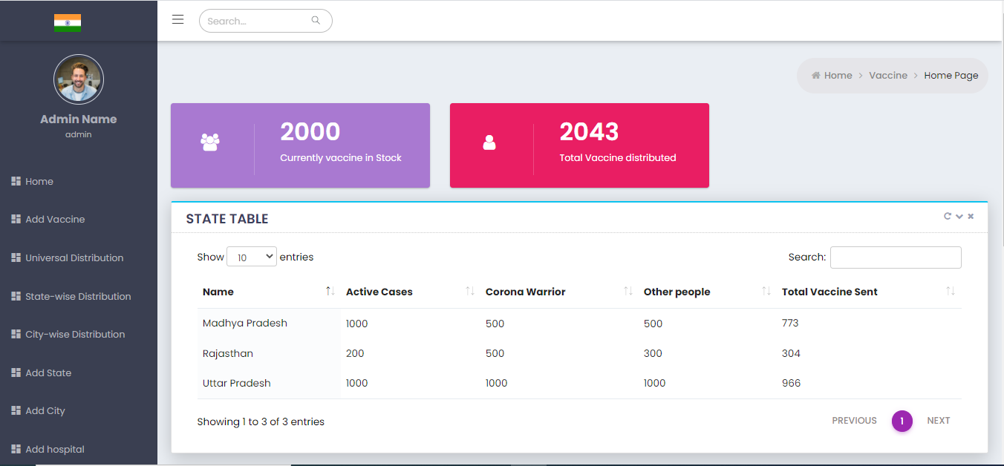

He will be authorized to add states and cities and hospitals as well.

The Admin user will have right to add/modify the vaccine details and its storage details .He/She will be authorized to add all the states their respective cities and ward into the system . Admin will be authorized to supply the vaccine to all the states according to the formula decided. He will have the record of all vaccines distributed till now and he can supply vaccines to cities or hospitals directly also.

1. **State User**

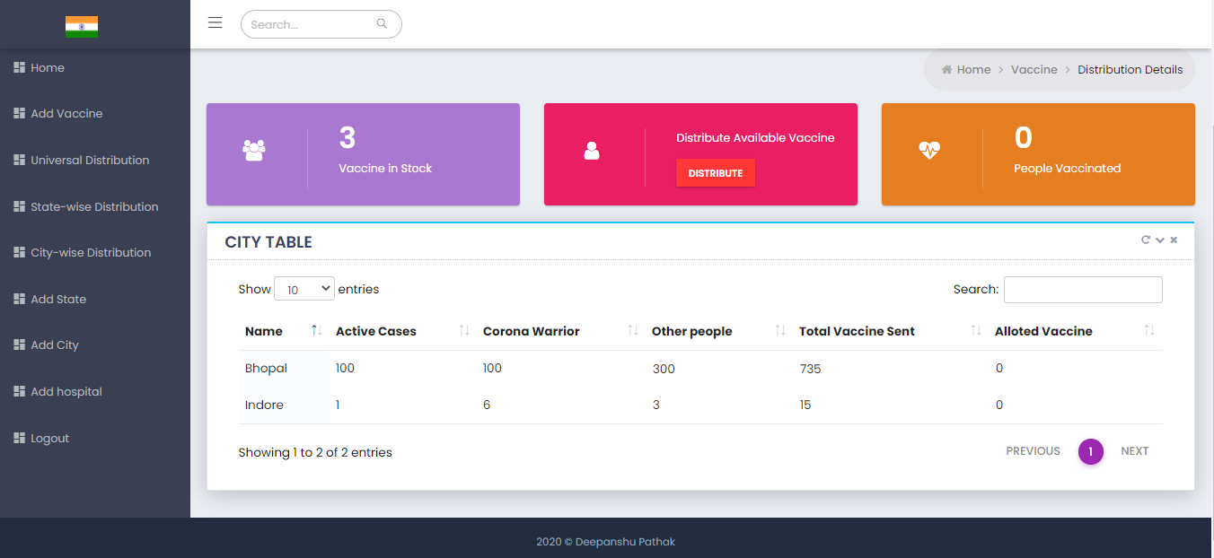

The state user will receive the vaccines sent to it by the admin user. The state user will be authorized to distribute these vaccines among different cities of its state. He will also be authorized to add different cities of its state into the system.

1. **City User**

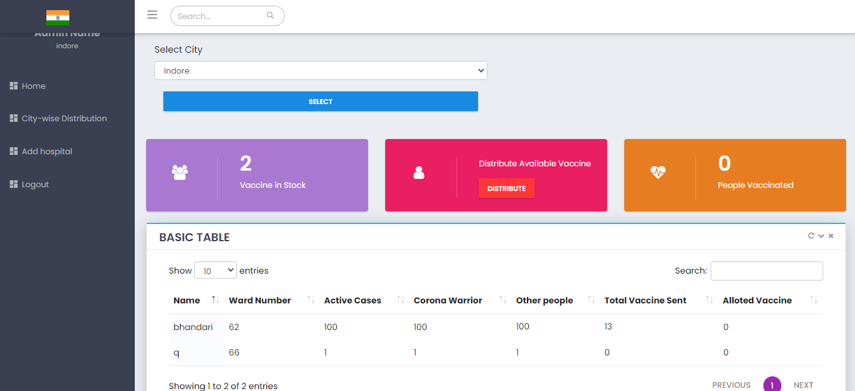

The city user will receive the vaccines sent to it by the state user. The city user will be authorized to distribute these vaccines among different wards of its state. He will also be authorized to add different hospitals of its city into the system.

1. **Hospital User**

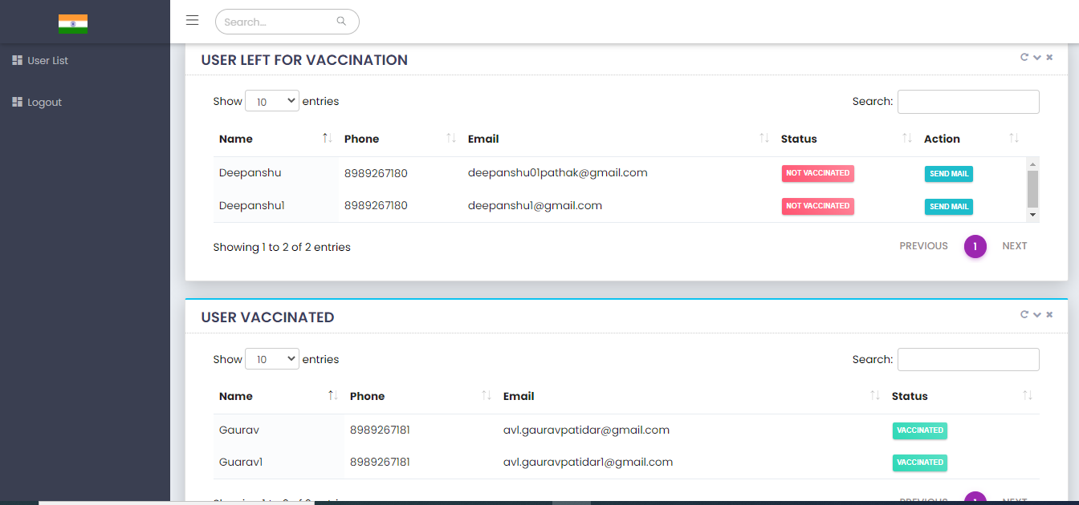

For smooth supply chain we will divide the city into number of wards and each ward will have a particular hospital where all the people of that particular ward will be vaccinated. So this ward user will receive the vaccine distributed by the city user and will supply it to the people. He/She will be able to view the list of user who are vaccinated and who are not vaccinated .He will be authorized to send mail to non-vaccinated people to ask them to come for vaccination.

**Overall Structure of project**

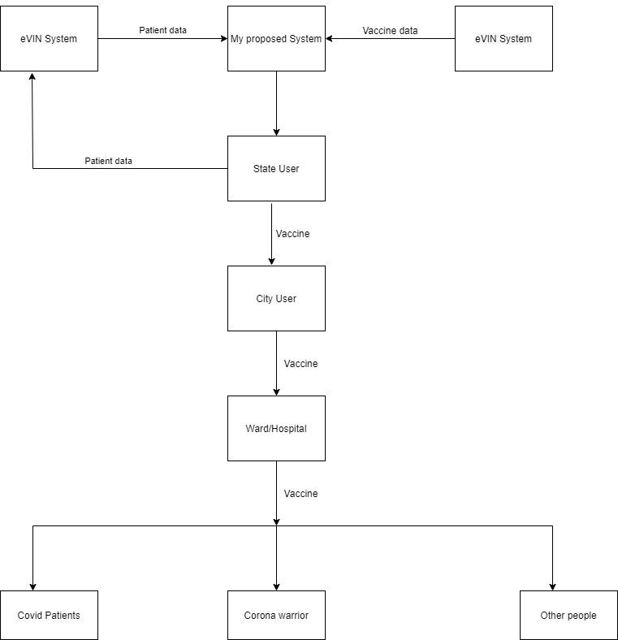

**ER DIAGRAM**

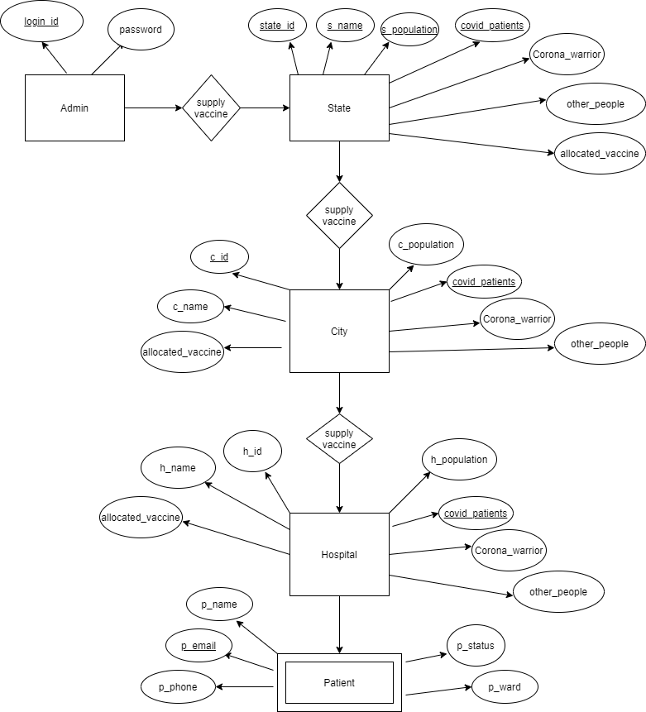

**Programming Language**

**JSP(JAVA SERVER PAGES)**

The Java Server Pages (JSP) is a server-side programming technology technology that enables the creation of dynamic, platform independent method for building Web-based applications .JSP have access to the entire family of Java APIs, including the JDBC API to access enterprise database.

Java Server Pages often serve the same purpose as programs implemented using using the Common Gateway Interface (CGI) .But JSP offers several advantages in comparison with the CGI.

Java Server Page is an integral part of Java EE , a complete platform for enterprise class applications .This means that JSP can play a part in the simplest applications to the most complex and demanding .

The advantages of JSP are twofold .First ,the dynamic part is written in java ,not Visual Basic or other MS specific language , so it is more powerful and easier to use .Secondly ,it is portable to other operating system and non-Microsoft web servers .

**WHY JSP?**

1) One of the main reasons of using JSP in my system is that, JSP has access to all the major Java API's including JDBC.

2) JSP tags allow us to write Java code inside static HTML web pages.

3) It is more convenient to write regular HTML than to have println statements that generate HTML which is done in Servlets.

4) It is comparatively faster as it has access to all the Java API'S so there is no need of using any external API which might slow down the processing of system.

5) The advantages of JSP are twofold .First ,the dynamic part is written in java ,not Visual Basic or other MS specific language , so it is more powerful and easier to use .Secondly ,it is portable to other operating system and non-Microsoft web servers .

**CODE**

**1)Login.jsp**

<div class="row">

<div class="col-sm-6">

<div class="card-box">

<form method="post" action="logindb.jsp">

<div class="card-body row">

<div class="col-lg-6 p-t-20">

<div class = "mdl-textfield mdl-js-textfield mdl-textfield--floating-label txt-full-width">

<input class = "mdl-textfield__input" type = "text" name="name">

<label class = "mdl-textfield__label">Enter Userame</label>

</div>

</div></div>

<div class="card-body row">

<div class="col-lg-6 p-t-20">

<div class = "mdl-textfield mdl-js-textfield mdl-textfield--floating-label txt-full-width">

<input class = "mdl-textfield__input" type = "password" name="password">

<label class = "mdl-textfield__label">Enter Password</label>

</div>

</div>

<div class="col-lg-12 p-t-20 text-center">

<button type="submit" name="submit" id="submit" value="submit" class="mdl-button mdl-js-button mdl-button--raised mdl-js-ripple-effect m-b-10 m-r-20 btn-pink">Submit</button>

<button type="button" class="mdl-button mdl-js-button mdl-button--raised mdl-js-ripple-effect m-b-10 btn-default">Cancel</button>

</div>

</div>

</form>

</div>

</div>

</div>

1.1)Logindb.jsp

<%@ page language="java" contentType="text/html; charset=ISO-8859-1"

pageEncoding="ISO-8859-1"%>

<%@page import="java.sql.*,java.util.*"%>

<%@ taglib uri="http://java.sun.com/jsp/jstl/core" prefix="c" %>

<%

try

{

String sname=request.getParameter("name");

String spass=request.getParameter("password");

if(sname.equals("")){

out.write("alert('Enter Username !!')");

}

if(spass.equals("")){

out.write("alert('Enter Password !!')");

}

if(!sname.equals("") && !spass.equals(""))

{

Class.forName("com.mysql.jdbc.Driver");

Connection con=DriverManager.getConnection(

"jdbc:mysql://localhost:3306/covid","root","");

Statement stmt=con.createStatement();

String sql="select * from login_data where username='"+sname+"' and password ='"+spass+"'";

ResultSet rs= stmt.executeQuery(sql);

while(rs.next()){

int status=rs.getInt("status");

if(status==0){

session.setAttribute("username",sname);

session.setAttribute("statusAdmin",0);

response.sendRedirect("./index.jsp");

}

if(status==1){

response.sendRedirect("./slogin.jsp");

}

if(status==2){

response.sendRedirect("./clogin.jsp");

}

}

if(!rs.next()){

out.write("alert('Invalid Username or Password !!')");

}

}

}

catch(Exception e)

{

System.out.print(e);

e.printStackTrace();

}

%>

2) Clogin.jsp

<div class="row">

<div class="col-sm-6">

<div class="card-box">

<div class="card-head">

<header></header>

</div>

<form method="post" action="clogindb.jsp">

<div class="card-body row">

<div class="col-lg-6 p-t-20">

<div class = "mdl-textfield mdl-js-textfield mdl-textfield--floating-label txt-full-width">

<input class = "mdl-textfield__input" type = "text" name="name">

<label class = "mdl-textfield__label">Enter Userame</label>

</div>

</div></div>

<div class="card-body row">

<div class="col-lg-6 p-t-20">

<div class = "mdl-textfield mdl-js-textfield mdl-textfield--floating-label txt-full-width">

<input class = "mdl-textfield__input" type = "password" name="password">

<label class = "mdl-textfield__label">Enter Password</label>

</div>

</div>

<div class="col-lg-12 p-t-20 text-center">

<button type="submit" name="submit" id="submit" value="submit" class="mdl-button mdl-js-button mdl-button--raised mdl-js-ripple-effect m-b-10 m-r-20 btn-pink">Submit</button>

button type="button" class="mdl-button mdl-js-button mdl-button--raised mdl-js-ripple-effect m-b-10 btn-default">Cancel</button>

</div>

</div>

</form>

</div>

</div>

</div>

**2.1 Clogindb.jsp**

<%@ page language="java" contentType="text/html; charset=ISO-8859-1"

pageEncoding="ISO-8859-1"%>

<%@page import="java.sql.*,java.util.*"%>

<%@ taglib uri="http://java.sun.com/jsp/jstl/core" prefix="c" %>

<%

try

{

String sname=request.getParameter("name");

String spass=request.getParameter("password");

if(sname.equals("")){

out.write("alert('Enter Username !!')");

}else if(spass.equals("")){

out.write("alert('Enter Password !!')");

}else if(!sname.equals(spass)) {

out.write("alert('Wrong Credentials !!')");

}else if(!sname.equals("") && !spass.equals("")) {

Class.forName("com.mysql.jdbc.Driver");

Connection con=DriverManager.getConnection(

"jdbc:mysql://localhost:3306/covid","root","");

Statement stmt=con.createStatement();

String sql="select * from city where name='"+sname+"' ";

ResultSet rs= stmt.executeQuery(sql);

while(rs.next()){

int status=rs.getInt("status");

if(status==2){

session.setAttribute("username",sname);

session.setAttribute("statusAdmin",2);

response.sendRedirect("./index.jsp");

}

}

if(!rs.next()){

out.write("alert('Invalid Username or Password !!')");

}}}

catch(Exception e)

{

System.out.print(e);

e.printStackTrace(); } %>

**3) Hlogin.jsp**

<div class="row">

<div class="col-sm-6">

<div class="card-box">

<div class="card-head">

</div>

<form method="post" action="hlogindb.jsp">

<div class="card-body row">

<div class="col-lg-6 p-t-20">

<div class = "mdl-textfield mdl-js-textfield mdl-textfield--floating-label txt-full-width">

<input class = "mdl-textfield__input" type = "text" name="name">

<label class = "mdl-textfield__label">Enter Userame</label>

</div>

</div></div>

<div class="card-body row">

<div class="col-lg-6 p-t-20">

<div class = "mdl-textfield mdl-js-textfield mdl-textfield--floating-label txt-full-width">

<input class = "mdl-textfield__input" type = "password" name="password">

<label class = "mdl-textfield__label">Enter Password</label>

</div>

</div>

<div class="col-lg-12 p-t-20 text-center">

<button type="submit" name="submit" id="submit" value="submit" class="mdl-button mdl-js-button mdl-button--raised mdl-js-ripple-effect m-b-10 m-r-20 btn-pink">Submit</button>

button type="button" class="mdl-button mdl-js-button mdl-button--raised mdl-js-ripple-effect m-b-10 btn-default">Cancel</button>

</div>

</div>

</form>

</div>

</div>

</div>

**3.1 Hlogindb.jsp**

<%@ page language="java" contentType="text/html; charset=ISO-8859-1"

pageEncoding="ISO-8859-1"%>

<%@page import="java.sql.*,java.util.*"%>

<%@ taglib uri="http://java.sun.com/jsp/jstl/core" prefix="c" %>

<%

try

{

String sname=request.getParameter("name");

String spass=request.getParameter("password");

if(sname.equals("")){

out.write("alert('Enter Username !!')");

}else if(spass.equals("")){

out.write("alert('Enter Password !!')");

}else if(!sname.equals("") && !spass.equals("")) {

Class.forName("com.mysql.jdbc.Driver");

Connection con=DriverManager.getConnection(

"jdbc:mysql://localhost:3306/covid","root","");

Statement stmt=con.createStatement();

String sql="select * from hospital where name='"+sname+"' and ward='"+spass+"' ";

ResultSet rs= stmt.executeQuery(sql);

while(rs.next()){

int status=rs.getInt("status");

String sward=rs.getString("ward");

if(status==3){

session.setAttribute("username",sname);

session.setAttribute("ward",sward);

session.setAttribute("statusAdmin",3);

response.sendRedirect("./index.jsp");

}} if(!rs.next()){

out.write("alert('Invalid Username or Password !!')");

} } }

catch(Exception e)

{

System.out.print(e);

e.printStackTrace();

}

%>

1. Index.jsp

<%@ page language="java" contentType="text/html; charset=ISO-8859-1"

pageEncoding="ISO-8859-1"%>

<%@page import="java.sql.*,java.util.*"%>

<%@ taglib uri="http://java.sun.com/jsp/jstl/core" prefix="c" %>

<%

try{

if(session.getAttribute("username") == null) {

response.sendRedirect("login.jsp");

return ;

}

String username=session.getAttribute("username").toString();

int status = Integer.parseInt(session.getAttribute("statusAdmin").toString());

pageContext.setAttribute("status", status);

%>

<c:set var="status" scope="session" value="${status}"/>

<%

try

{

Class.forName("com.mysql.jdbc.Driver");

Connection conn=DriverManager.getConnection(

"jdbc:mysql://localhost:3306/covid","root","");

Statement stmt1=conn.createStatement();

String sqll ="select * from vaccine";

ResultSet rss= stmt1.executeQuery(sqll);

while(rss.next()){

%>

<div class="profile-usertitle">

<div class="sidebar-userpic-name">Admin Name </div>

<divclass="profile-usertitle-job"> <%out.println(session.getAttribute("username").toString()); %> </div>

</div>

<div class="col-md-12">

<div class="card card-topline-aqua">

<div class="card-head">

<header>STATE TABLE</header>

<div class="tools">

<a class="fa fa-repeat btn-color box-refresh" href="javascript:;"></a>

<a class="t-collapse btn-color fa fa-chevron-down" href="javascript:;"></a>

<a class="t-close btn-color fa fa-times" href="javascript:;"></a>

</div></div>

<div class="card-body ">

<div class="table-scrollable">

<table id="example1" class="display full-width">

<thead>

<tr>

<th>Name</th>

<th>Active Cases</th>

<th>Corona Warrior</th>

<th>Other people</th>

<th>Total Vaccine Sent</th>

</tr>

</thead>

<tbody>

<%

try

{

Class.forName("com.mysql.jdbc.Driver");

Connection con=DriverManager.getConnection(

"jdbc:mysql://localhost:3306/covid","root","");

Statement stmt=con.createStatement();

String sql ="select * from state";

ResultSet rs= stmt.executeQuery(sql);

while(rs.next()){

%>

<tr>

<td><%= rs.getString("name") %></td>

<td><%= rs.getString("cp") %></td>

<td><%= rs.getString("cw") %></td>

<td><%= rs.getString("op") %></td>

<td><%= rs.getString("total_vaccine") %></td>

</tr>

<%

}

} catch (Exception e) {

e.printStackTrace();

}%>

</tbody>

</table>

</div></div></div></div>

<div class="col-md-12">

<div class="card card-topline-aqua">

<div class="card-head">

<header>CITY TABLE</header>

<div class="tools">

<a class="fa fa-repeat btn-color box-refresh" href="javascript:;"></a>

<a class="t-collapse btn-color fa fa-chevron-down" href="javascript:;"></a>

<a class="t-close btn-color fa fa-times" href="javascript:;"></a>

</div>

</div>

<div class="card-body ">

<div class="table-scrollable">

<table id="example4" class="display full-width">

<thead>

<tr>

<th>Name</th>

<th>Active Cases</th>

<th>Corona Warrior</th>

<th>Other people</th>

<th>Total Vaccine Sent</th>

</tr>

</thead>

<tbody>

<%

try

{

Class.forName("com.mysql.jdbc.Driver");

Connection con=DriverManager.getConnection(

"jdbc:mysql://localhost:3306/covid","root","");

Statement stmt=con.createStatement();

String sql ="select * from city";

ResultSet rs= stmt.executeQuery(sql);

while(rs.next()){

%>

<tr>

<td><%= rs.getString("name") %></td>

<td><%= rs.getString("cp") %></td>

<td><%= rs.getString("cw") %></td>

<td><%= rs.getString("op") %></td>

<td><%= rs.getString("total_vaccine") %></td>

</tr>

<%

}

} catch (Exception e) {

e.printStackTrace();

}

%>

</tbody>

</table>

</div>

</div>

</div>

</div>

1. **Dist_vaccine.jsp**

<%@ page language="java" contentType="text/html; charset=ISO-8859-1"

pageEncoding="ISO-8859-1"%>

<%@page import="java.sql.*,java.util.*"%>

<%@ taglib uri="http://java.sun.com/jsp/jstl/core" prefix="c" %>

<%

if(session.getAttribute("username") == null) {

response.sendRedirect("login.jsp");

return ;

}

int total_vc = 0;

int alloted=0;

int cptotal=0;

int cwtotal=0;

int optotal=0;

try

{

int status = Integer.parseInt(session.getAttribute("statusAdmin").toString());

pageContext.setAttribute("status", status);

Class.forName("com.mysql.jdbc.Driver");

Connection conn=DriverManager.getConnection("jdbc:mysql://localhost:3306/covid","root","");

Statement stmt1=conn.createStatement();

String sqll ="select * from vaccine";

ResultSet rss= stmt1.executeQuery(sqll);

while(rss.next()){

total_vc=rss.getInt("no_of_vaccine");

%>

<c:set var="status" scope="session" value="${status}"/>

<title>COVID-19 | State distribution</title>

<script>

function changeTotalNo(){

document.getElementById('distrubutenow').style.display = "none";

document.getElementById('statetable1').style.display = "none";

document.getElementById('statetable2').style.display = "block";

}

</script>

<div class="value white">

<p class="sbold addr-font-h1" data-counter="counterup">

<% out.println(rss.getString("no_of_vaccine")); %>

</p>

<p>Vaccine in Stock</p>

<%

}

}

catch(Exception e)

{

System.out.print(e);

e.printStackTrace();

}

%>

</div>

<div class="col-sm-12">

<div class="row">

<div class="col-md-12">

<div class="card card-topline-aqua">

<div class="card-head">

<header>STATE TABLE</header>

<div class="tools">

<a class="fa fa-repeat btn-color box-refresh" href="javascript:;"></a>

<a class="t-collapse btn-color fa fa-chevron-down" href="javascript:;"></a>

<a class="t-close btn-color fa fa-times" href="javascript:;"></a>

</div>

</div>

<div class="card-body ">

<div class="table-scrollable">

<table id="example4" class="display full-width">

<thead>

<tr>

<th>Name</th>

<th>Active Cases</th>

<th>Corona Warrior</th>

<th>Other people</th>

<th>Total Vaccine Sent</th>

<th>Alloted Vaccine</th>

</tr>

</thead>

<tbody>

<%

try

{

Class.forName("com.mysql.jdbc.Driver");

Connection con=DriverManager.getConnection(

"jdbc:mysql://localhost:3306/covid","root","");

Statement stmt=con.createStatement();

String sqlfinal="select sum(cp),sum(cw),sum(op) from state";

ResultSet rsfinal= stmt.executeQuery(sqlfinal);

while(rsfinal.next()){

cptotal=rsfinal.getInt(1);

cwtotal=rsfinal.getInt(2);

optotal=rsfinal.getInt(3);

}

String sql ="select * from state";

ResultSet rs= stmt.executeQuery(sql);

while(rs.next()){

int cp=0;

int cw=0;

int op=0;

alloted=(rs.getInt("cp")*60*total_vc)/(100*cptotal)

+(rs.getInt("cw")*25*total_vc)/(100*cwtotal)

+(rs.getInt("op")*15*total_vc)/(100*optotal);

%>

<tr>

<td><%= rs.getString("name") %></td>

<td><%= rs.getString("cp") %></td>

<td><%= rs.getString("cw") %></td>

<td><%= rs.getString("op") %></td>

<td><%= rs.getString("total_vaccine") %></td>

<td><% out.println(alloted); %></td>

</tr>

<%

}

} catch (Exception e) {

e.printStackTrace();

}

%>

</tbody>

</table>

</div>

</div>

<FORM NAME="form1" METHOD="POST">

<INPUT TYPE="HIDDEN" NAME="buttonName">

<button type="button" class="btn btn-round btn-primary" style="width:40%;margin-left:30%;margin-bottom: 20px;" onclick="sendVaccine()">Send Vaccine</button><br>

</FORM>

<%

if(request.getParameter("buttonName") != null) {

int tominus = total_vc;

try

{

Class.forName("com.mysql.jdbc.Driver");

Connection con=DriverManager.getConnection(

"jdbc:mysql://localhost:3306/covid","root","");

Statement stmt=con.createStatement();

Statement stmt1=con.createStatement();

String sql ="select * from state";

ResultSet rs= stmt.executeQuery(sql);

while(rs.next()){

int id=rs.getInt("id");

int cp=0;

int cw=0;

int op=0;

int totalvacciness=rs.getInt("total_vaccine");

int vis=rs.getInt("allocated_vaccine");

int alloteds=(rs.getInt("cp")*60*total_vc)/(100*cptotal)

+(rs.getInt("cw")*25*total_vc)/(100*cwtotal)

+(rs.getInt("op")*15*total_vc)/(100*optotal);

totalvacciness = totalvacciness + alloteds;

vis = vis + alloteds;

tominus = tominus - alloteds;

String sqls="update state set total_vaccine='"+totalvacciness+"',allocated_vaccine='"+vis+"' where id='"+id+"'";

stmt1.executeUpdate(sqls);

}

String sqls="update vaccine set no_of_vaccine='"+tominus+"'";

stmt1.executeUpdate(sqls);

response.sendRedirect("./dist_vaccine.jsp?id=1");

}

catch(Exception e)

{

System.out.print(e);

e.printStackTrace();

}

}

%>

<SCRIPT LANGUAGE="JavaScript">

function sendVaccine()

{

document.form1.buttonName.value = "yes";

form1.submit();

}

</SCRIPT>

</div>

</div>

</div>

</div>

<div class="col-sm-12">

<div class="row">

<div class="col-md-12">

<div class="card card-topline-aqua">

<div class="card-head">

<header>STATE TABLE</header>

<div class="tools">

<a class="fa fa-repeat btn-color box-refresh" href="javascript:;"></a>

<a class="t-collapse btn-color fa fa-chevron-down" href="javascript:;"></a>

<a class="t-close btn-color fa fa-times" href="javascript:;"></a>

</div>

</div>

<div class="card-body ">

<div class="table-scrollable">

<table id="example1" class="display full-width">

<thead>

<tr>

<th>Name</th>

<th>Active Cases</th>

<th>Corona Warrior</th>

<th>Other people</th>

<th>Total Vaccine Sent</th>

<th>Alloted Vaccine</th>

</tr>

</thead>

<tbody>

<%

try

{

Class.forName("com.mysql.jdbc.Driver");

Connection con=DriverManager.getConnection(

"jdbc:mysql://localhost:3306/covid","root","");

Statement stmt=con.createStatement();

String sql ="select * from state";

ResultSet rs= stmt.executeQuery(sql);

while(rs.next()){

%>

<tr>

<td><%= rs.getString("name") %></td>

<td><%= rs.getString("cp") %></td>

<td><%= rs.getString("cw") %></td>

<td><%= rs.getString("op") %></td>

<td><%= rs.getString("total_vaccine") %></td>

<td>0</td>

</tr>

<%

}

} catch (Exception e) {

e.printStackTrace();

}

%>

</tbody>

</table>

</div>

</div>

</div>

</div>

</div>

</div>

</div>

<script>

document.getElementById('statetable1').style.display = "block";

document.getElementById('statetable2').style.display = "none";

</script>

1. **dist_state.jsp**

<%@ page language="java" contentType="text/html; charset=ISO-8859-1"

pageEncoding="ISO-8859-1"%>

<%@page import="java.sql.*,java.util.*"%>

<%@ taglib uri="http://java.sun.com/jsp/jstl/core" prefix="c" %>

<%

if(session.getAttribute("username") == null) {

response.sendRedirect("login.jsp");

return ;

}

String stateID = request.getParameter("sid");

int total_vc = 0;

int alloted=0;

int cptotal=0;

int cwtotal=0;

int optotal=0;

try

{

int status = Integer.parseInt(session.getAttribute("statusAdmin").toString());

pageContext.setAttribute("status", status);

Class.forName("com.mysql.jdbc.Driver");

Connection conn=DriverManager.getConnection("jdbc:mysql://localhost:3306/covid","root","");

Statement stmt1=conn.createStatement();

String sqll ="select * from state where id='"+stateID+"'";

ResultSet rss= stmt1.executeQuery(sqll);

while(rss.next()){

total_vc=rss.getInt("allocated_vaccine");

%>

<c:set var="status" scope="session" value="${status}"/>

<title>COVID-19 | City distribution</title>

<div class="profile-usertitle">

<div class="sidebar-userpic-name">Admin Name </div>

<divclass="profile-usertitle-job"> <%out.println(session.getAttribute("username").toString()); %> </div>

</div>

<div class="col-lg-6 p-t-20">

<div class="mdl-textfield mdl-js-textfield mdl-textfield--floating-label getmdl-select getmdl-select__fix-height txt-full-width">

<label for="simpleFormEmail">Select State</label>

<select class="form-control" name="sel" id="sel" onchange="{doSomething()}" required>

<%

Connection conns=DriverManager.getConnection("jdbc:mysql://localhost:3306/covid","root","");

Statement stmt1s=conns.createStatement();

String sqlls ="select * from state";

ResultSet rsss= stmt1s.executeQuery(sqlls);

while(rsss.next()){

%>

<option value="<%= rsss.getString(1) %>"><%= rsss.getString("name") %></option>

<%

}

%>

</select>

</div>

</div>

<FORM NAME="formState" METHOD="POST">

<INPUT TYPE="HIDDEN" NAME="hiddenButton">

<button type="button" class="btn btn-round btn-primary" style="width:40%;margin-left: 35px;" onclick="selectState()">Select</button><br>

</FORM>

<script>

function selectState(){

var x = $('#sel').val();

window.location.href='./dist_state.jsp?sid='+x;

}

</script>

<script>

function changeTotalNo(){

document.getElementById('distrubutenow').style.display = "none";

document.getElementById('statetable1').style.display = "none";

document.getElementById('statetable2').style.display = "block";

}

</script>

<% out.println(total_vc); %>

</p>

<p>Vaccine in Stock</p>

<%

}

}

catch(Exception e)

{

System.out.print(e);

e.printStackTrace();

}

%>

<p>Distribute Available Vaccine</p>

<button type="button" class="btn btn-round btn-danger" id="distrubutenow" onclick="changeTotalNo()">Distribute</button>

<div class="col-md-12">

<div class="card card-topline-aqua">

<div class="card-head">

<header>CITY TABLE</header>

<div class="tools">

<a class="fa fa-repeat btn-color box-refresh" href="javascript:;"></a>

<a class="t-collapse btn-color fa fa-chevron-down" href="javascript:;"></a>

<a class="t-close btn-color fa fa-times" href="javascript:;"></a>

</div>

</div>

<div class="card-body ">

<div class="table-scrollable">

<table id="example4" class="display full-width">

<thead>

<tr>

<th>Name</th>

<th>Active Cases</th>

<th>Corona Warrior</th>

<th>Other people</th>

<th>Total Vaccine Sent</th>

<th>Alloted Vaccine</th>

</tr>

</thead>

<tbody>

<%

try

{

Class.forName("com.mysql.jdbc.Driver");

Connection con=DriverManager.getConnection(

"jdbc:mysql://localhost:3306/covid","root","");

Statement stmt=con.createStatement();

String sqlfinal="select sum(cp),sum(cw),sum(op) from city where s_id='"+stateID+"'";

ResultSet rsfinal= stmt.executeQuery(sqlfinal);

while(rsfinal.next()){

cptotal=rsfinal.getInt(1);

cwtotal=rsfinal.getInt(2);

optotal=rsfinal.getInt(3);

}

String sql ="select * from city where s_id='"+stateID+"'";

ResultSet rs= stmt.executeQuery(sql);

while(rs.next()){

int cp=0;

int cw=0;

int op=0;

alloted=(rs.getInt("cp")*60*total_vc)/(100*cptotal)

+(rs.getInt("cw")*25*total_vc)/(100*cwtotal)

+(rs.getInt("op")*15*total_vc)/(100*optotal);

%>

<tr>

<td><%= rs.getString("name") %></td>

<td><%= rs.getString("cp") %></td>

<td><%= rs.getString("cw") %></td>

<td><%= rs.getString("op") %></td>

<td><%= rs.getString("total_vaccine") %></td>

<td><% out.println(alloted); %></td>

</tr>

<%

}

} catch (Exception e) {

e.printStackTrace();

}

%>

</tbody>

</table>

</div>

</div>

<FORM NAME="form1" METHOD="POST">

<INPUT TYPE="HIDDEN" NAME="buttonName">

<button type="button" class="btn btn-round btn-primary" style="width:40%;margin-left:30%;margin-bottom: 20px;" onclick="sendVaccine()">Send Vacine</button><br>

</FORM>

<%

if(request.getParameter("buttonName") != null) {

int tominus = total_vc;

try

{

Class.forName("com.mysql.jdbc.Driver");

Connection con=DriverManager.getConnection(

"jdbc:mysql://localhost:3306/covid","root","");

Statement stmt=con.createStatement();

Statement stmt1=con.createStatement();

String sql ="select * from city where s_id='"+stateID+"'";

ResultSet rs= stmt.executeQuery(sql);

while(rs.next()){

int id=rs.getInt("id");

int cp=0;

int cw=0;

int op=0;

int totalvacciness=rs.getInt("total_vaccine");

int vis=rs.getInt("allocated_vaccine");

int alloteds=(rs.getInt("cp")*60*total_vc)/(100*cptotal)

+(rs.getInt("cw")*25*total_vc)/(100*cwtotal)

+(rs.getInt("op")*15*total_vc)/(100*optotal);

totalvacciness = totalvacciness + alloteds;

vis = vis + alloteds;

tominus = tominus - alloteds;

String sqls="update city set total_vaccine='"+totalvacciness+"',allocated_vaccine='"+vis+"' where id='"+id+"'";

stmt1.executeUpdate(sqls);

}

String sqls="update state set allocated_vaccine='"+tominus+"' where id='"+stateID+"'";

stmt1.executeUpdate(sqls);

response.sendRedirect("./dist_state.jsp?sid="+stateID);

}

catch(Exception e)

{

System.out.print(e);

e.printStackTrace();

}

}

%>

</div>

</div>

<div class="col-md-12">

<div class="card card-topline-aqua">

<div class="card-head">

<header>CITY TABLE</header>

<div class="tools">

<a class="fa fa-repeat btn-color box-refresh" href="javascript:;"></a>

<a class="t-collapse btn-color fa fa-chevron-down" href="javascript:;"></a>

<a class="t-close btn-color fa fa-times" href="javascript:;"></a>

</div></div>

<div class="card-body ">

<div class="table-scrollable">

<table id="example1" class="display full-width">

<thead>

<tr>

<th>Name</th>

<th>Active Cases</th>

<th>Corona Warrior</th>

<th>Other people</th>

<th>Total Vaccine Sent</th>

<th>Alloted Vaccine</th>

</tr>

</thead>

<tbody>

<%

try

{

Class.forName("com.mysql.jdbc.Driver");

Connection con=DriverManager.getConnection(

"jdbc:mysql://localhost:3306/covid","root","");

Statement stmt=con.createStatement();

String sql ="select * from city where s_id='"+stateID+"'";

ResultSet rs= stmt.executeQuery(sql);

while(rs.next()){

%>

<tr>

<td><%= rs.getString("name") %></td>

<td><%= rs.getString("cp") %></td>

<td><%= rs.getString("cw") %></td>

<td><%= rs.getString("op") %></td>

<td><%= rs.getString("total_vaccine") %></td>

<td>0</td>

</tr>

<%

}

} catch (Exception e) {

e.printStackTrace();

}

%>

</tbody>

</table>

</div>

</div></div></div></div></div>

1. **dist_city.jsp**

<%@ page language="java" contentType="text/html; charset=ISO-8859-1"

pageEncoding="ISO-8859-1"%>

<%@page import="java.sql.*,java.util.*"%>

<%@ taglib uri="http://java.sun.com/jsp/jstl/core" prefix="c" %>

<%

if(session.getAttribute("username") == null) {

response.sendRedirect("login.jsp");

return ;

}

String stateID = request.getParameter("cid");

int total_vc = 0;

int alloted=0;

int cptotal=0;

int cwtotal=0;

int optotal=0;

try{

int status = Integer.parseInt(session.getAttribute("statusAdmin").toString());

pageContext.setAttribute("status", status);

Class.forName("com.mysql.jdbc.Driver");

Connection conn=DriverManager.getConnection("jdbc:mysql://localhost:3306/covid","root","");

Statement stmt1=conn.createStatement();

String sqll ="select * from city where id='"+stateID+"'";

ResultSet rss= stmt1.executeQuery(sqll);

while(rss.next()){

total_vc=rss.getInt("allocated_vaccine");

%>

<c:set var="status" scope="session" value="${status}"/>

<title>COVID-19 | Local distribution</title>

<div class="profile-usertitle">

<div class="sidebar-userpic-name">Admin Name </div>

<divclass="profile-usertitle-job"> <%out.println(session.getAttribute("username").toString()); %> </div>

</div>

<div class="col-lg-6 p-t-20">

<div class="mdl-textfield mdl-js-textfield mdl-textfield--floating-label getmdl-select getmdl-select__fix-height txt-full-width">

<label for="simpleFormEmail">Select City</label>

<select class="form-control" name="sel" id="sel" onchange="{doSomething()}" required>

<%

Connection conns=DriverManager.getConnection("jdbc:mysql://localhost:3306/covid","root","");

Statement stmt1s=conns.createStatement();

String sqlls ="select * from city";

ResultSet rsss= stmt1s.executeQuery(sqlls);

while(rsss.next()){

%>

<option value="<%= rsss.getString(1) %>"><%= rsss.getString("name") %></option>

<%

}

%>

</select>

</div>

</div>

<FORM NAME="formState" METHOD="POST">

<INPUT TYPE="HIDDEN" NAME="hiddenButton">

<button type="button" class="btn btn-round btn-primary" style="width: 45%;margin-left: 30px;" onclick="selectState()">Select</button><br>

</FORM><br><br>

<script>

function selectState(){

var x = $('#sel').val();

window.location.href='./dist_city.jsp?cid='+x;

}

</script>

<div class="state-overview">

<div class="row">

<div class="col-lg-4 col-sm-6">

<div class="overview-panel purple">

<div class="symbol">

<i class="fa fa-users usr-clr"></i>

</div>

<div class="value white">

<p class="sbold addr-font-h1" data-counter="counterup">

<% out.println(total_vc); %>

</p>

<p>Vaccine in Stock</p>

<%

}

}

catch(Exception e)

{

System.out.print(e);

e.printStackTrace();

}

%>

<div class="col-md-12">

<div class="card card-topline-aqua">

<div class="card-head">

<header>BASIC TABLE</header>

<div class="tools">

<a class="fa fa-repeat btn-color box-refresh" href="javascript:;"></a>

<a class="t-collapse btn-color fa fa-chevron-down" href="javascript:;"></a>

<a class="t-close btn-color fa fa-times" href="javascript:;"></a>

</div>

</div>

<div class="card-body ">

<div class="table-scrollable">

<table id="example4" class="display full-width">

<thead>

<tr>

<th>Name</th>

<th>Ward Number</th>

<th>Active Cases</th>

<th>Corona Warrior</th>

<th>Other people</th>

<th>Total Vaccine Sent</th>

<th>Alloted Vaccine</th>

</tr>

</thead>

<tbody>

<%

try

{

Class.forName("com.mysql.jdbc.Driver");

Connection con=DriverManager.getConnection(

"jdbc:mysql://localhost:3306/covid","root","");

Statement stmt=con.createStatement();

String sqlfinal="select sum(cp),sum(cw),sum(op) from hospital where c_id='"+stateID+"'";

ResultSet rsfinal= stmt.executeQuery(sqlfinal);

while(rsfinal.next()){

cptotal=rsfinal.getInt(1);

cwtotal=rsfinal.getInt(2);

optotal=rsfinal.getInt(3);

}

String sql ="select * from hospital where c_id='"+stateID+"'";

ResultSet rs= stmt.executeQuery(sql);

while(rs.next()){

int cp=0;

int cw=0;

int op=0;

alloted=(rs.getInt("cp")*60*total_vc)/(100*cptotal)

+(rs.getInt("cw")*25*total_vc)/(100*cwtotal)

+(rs.getInt("op")*15*total_vc)/(100*optotal);

%>

<tr>

<td><%= rs.getString("name") %></td>

<td><%= rs.getString("ward") %></td>

<td><%= rs.getString("cp") %></td>

<td><%= rs.getString("cw") %></td>

<td><%= rs.getString("op") %></td>

<td><%= rs.getString("total_vaccine") %></td>

<td><% out.println(alloted); %></td>

</tr>

<%

}

} catch (Exception e) {

e.printStackTrace();

}

%>

</tbody>

</table>

</div>

</div>

<FORM NAME="form1" METHOD="POST">

<INPUT TYPE="HIDDEN" NAME="buttonName">

<button type="button" class="btn btn-round btn-primary" style="width:40%;margin-left:30%;margin-bottom: 20px;" onclick="sendVaccine()">Send Vaccine</button><br>

</FORM>

<%

if(request.getParameter("buttonName") != null) {

int tominus = total_vc;

try

{

Class.forName("com.mysql.jdbc.Driver");

Connection con=DriverManager.getConnection(

"jdbc:mysql://localhost:3306/covid","root","");

Statement stmt=con.createStatement();

Statement stmt1=con.createStatement();

String sql ="select * from hospital where c_id='"+stateID+"'";

ResultSet rs= stmt.executeQuery(sql);

while(rs.next()){

int id=rs.getInt("id");

int cp=0;

int cw=0;

int op=0;

int totalvacciness=rs.getInt("total_vaccine");

int vis=rs.getInt("allocated_vaccine");

int alloteds=(rs.getInt("cp")*60*total_vc)/(100*cptotal)

+(rs.getInt("cw")*25*total_vc)/(100*cwtotal)

+(rs.getInt("op")*15*total_vc)/(100*optotal);

totalvacciness = totalvacciness + alloteds;

vis = vis + alloteds;

tominus = tominus - alloteds;

String sqls="update hospital set total_vaccine='"+totalvacciness+"',allocated_vaccine='"+vis+"' where id='"+id+"'";

stmt1.executeUpdate(sqls);

}

String sqls="update city set allocated_vaccine='"+tominus+"' where id='"+stateID+"'";

stmt1.executeUpdate(sqls);

response.sendRedirect("./dist_city.jsp?cid="+stateID);

}

catch(Exception e)

{

System.out.print(e);

e.printStackTrace();

}

}

%>

<SCRIPT LANGUAGE="JavaScript">

function sendVaccine()

{

document.form1.buttonName.value = "yes";

form1.submit();

}

</SCRIPT>

</div>

</div>

1. **addstate.html**

<form method="post" action="addstatedb.jsp">

<div class="card-body row">

<div class="col-lg-6 p-t-20">

<div class = "mdl-textfield mdl-js-textfield mdl-textfield--floating-label txt-full-width">

<input class = "mdl-textfield__input" type = "text" name="name" required>

<label class = "mdl-textfield__label">State Name</label>

</div>

</div>

<div class="col-lg-6 p-t-20">

<div class = "mdl-textfield mdl-js-textfield mdl-textfield--floating-label txt-full-width">

<input class = "mdl-textfield__input" type = "text" name="population" required>

<label class = "mdl-textfield__label">State Population</label>

</div>

</div>

<div class="col-lg-6 p-t-20">

<div class = "mdl-textfield mdl-js-textfield mdl-textfield--floating-label txt-full-width">

<input class = "mdl-textfield__input" type = "text" name="tcp" required>

<label class = "mdl-textfield__label">Total Covid Patients</label>

</div>

</div>

<div class="col-lg-6 p-t-20">

<div class = "mdl-textfield mdl-js-textfield mdl-textfield--floating-label txt-full-width">

<input class = "mdl-textfield__input" type = "text" name="tcw" required>

<label class = "mdl-textfield__label">Total Corona Warrior</label>

</div>

</div>

<div class="col-lg-6 p-t-20">

<div class = "mdl-textfield mdl-js-textfield mdl-textfield--floating-label txt-full-width">

<input class = "mdl-textfield__input" type = "text" name="rp" required>

<label class = "mdl-textfield__label">Remaining People</label>

</div>

</div>

<div class="col-lg-12 p-t-20 text-center">

<button type="submit" name="submit" id="submit" value="submit" class="mdl-button mdl-js-button mdl-button--raised mdl-js-ripple-effect m-b-10 m-r-20 btn-pink">Submit</button>

<button type="button" class="mdl-button mdl-js-button mdl-button--raised mdl-js-ripple-effect m-b-10 btn-default">Cancel</button>

</div>

</div>

</form>

**8.1) Addstatedb.jsp**

<%@ page language="java" contentType="text/html; charset=ISO-8859-1"

pageEncoding="ISO-8859-1"%>

<%@page import="java.sql.*,java.util.*"%>

<%@ taglib uri="http://java.sun.com/jsp/jstl/core" prefix="c" %>

<%

try

{

if(session.getAttribute("username") == null) {

response.sendRedirect("login.jsp");

return ;

}

String sname=request.getParameter("name");

String spopulation=request.getParameter("population");

String stcp=request.getParameter("tcp");

String stcw=request.getParameter("tcw");

String srp=request.getParameter("rp");

if(sname.equals("")){

out.write("alert('Enter State name !!')");

}

if(spopulation.equals("")){

out.write("alert('Enter population !!')");

}

if(stcp.equals("")){

out.write("alert('Enter Total Covid Patients !!')");

}

if(stcw.equals("")){

out.write("alert('Enter Total Covid Warriors !!')");

}

if(srp.equals("")){

out.write("alert('Enter Remaining Pople !!')");

}

if(sname != " "){

Class.forName("com.mysql.jdbc.Driver");

Connection con=DriverManager.getConnection(

"jdbc:mysql://localhost:3306/covid","root","");

Statement stmt=con.createStatement();

String sql="insert into state(population,name,cp,cw,op) values('"+spopulation+"','"+sname+"','"+stcp+"','"+stcw+"','"+srp+"')";

stmt.executeUpdate(sql);

response.sendRedirect("./addstate.html");

}}

catch(Exception e)

{

System.out.print(e);

e.printStackTrace();

}

%>

**9)Addcity.html**

<form method="post" action="addcitydb.jsp">

<div class="card-body row">

<div class="col-lg-6 p-t-20">

<div class = "mdl-textfield mdl-js-textfield mdl-textfield--floating-label txt-full-width">

<input class = "mdl-textfield__input" type = "text" name="name" required>

<label class = "mdl-textfield__label">City Name</label>

</div>

</div>

<div class="col-lg-6 p-t-20">

<div class = "mdl-textfield mdl-js-textfield mdl-textfield--floating-label txt-full-width">

<input class = "mdl-textfield__input" type = "text" name="population" required>

<label class = "mdl-textfield__label">City Population</label>

</div>

</div>

<div class="col-lg-6 p-t-20">

<div class = "mdl-textfield mdl-js-textfield mdl-textfield--floating-label txt-full-width">

<input class = "mdl-textfield__input" type = "text" name="tcp" required>

<label class = "mdl-textfield__label">Total Covid Patients</label>

</div>

</div>

<div class="col-lg-6 p-t-20">

<div class = "mdl-textfield mdl-js-textfield mdl-textfield--floating-label txt-full-width">

<input class = "mdl-textfield__input" type = "text" name="tcw" required>

<label class = "mdl-textfield__label">Total Corona Warrior</label>

</div></div>

<div class="col-lg-6 p-t-20">

<div class = "mdl-textfield mdl-js-textfield mdl-textfield--floating-label txt-full-width">

<input class = "mdl-textfield__input" type = "text" name="rp" required>

<label class = "mdl-textfield__label">Remaining People</label>

</div></div>

<div class="col-lg-12 p-t-20 text-center">

<button type="submit" name="submit" id="submit" value="submit" class="mdl-button mdl-js-button mdl-button--raised mdl-js-ripple-effect m-b-10 m-r-20 btn-pink">Submit</button>

<button type="button" class="mdl-button mdl-js-button mdl-button--raised mdl-js-ripple-effect m-b-10 btn-default">Cancel</button>

</div></div>

</form>

**9.1) Addcitydb.jsp**

<%@ page language="java" contentType="text/html; charset=ISO-8859-1"

pageEncoding="ISO-8859-1"%>

<%@page import="java.sql.*,java.util.*"%>

<%@ taglib uri="http://java.sun.com/jsp/jstl/core" prefix="c" %>

<%

try

{ if(session.getAttribute("username") == null) {

response.sendRedirect("login.jsp");

return ; }

String sname=request.getParameter("name");

String spopulation=request.getParameter("population");

String stcp=request.getParameter("tcp");

String stcw=request.getParameter("tcw");

String srp=request.getParameter("rp");

String ssel=request.getParameter("sel");

Class.forName("com.mysql.jdbc.Driver");

Connection con=DriverManager.getConnection(

"jdbc:mysql://localhost:3306/covid","root","");

Statement stmt=con.createStatement();

Statement stmt1=con.createStatement();

String sql="Select id from state where name='"+ssel+"'";

ResultSet rs= stmt.executeQuery(sql);

while(rs.next()){

String stateid=rs.getString("id");

String sqll="insert into city(population,name,cp,cw,op,s_id) values('"+spopulation+"','"+sname+"','"+stcp+"','"+stcw+"','"+srp+"','"+stateid+"') ";

stmt.executeUpdate(sqll);

response.sendRedirect("./addcity2.jsp");

}}

catch(Exception e){

System.out.print(e);

e.printStackTrace();

} %>

**10)addhospital.jsp**

<form method="post" action="addhospitaldb.jsp">

<div class="card-body row">

<div class="col-lg-6 p-t-20">

<div class="mdl-textfield mdl-js-textfield mdl-textfield--floating-label getmdl-select getmdl-select__fix-height txt-full-width">

<select class="form-control" name="sel" id="sel" required>

<%

Connection conns=DriverManager.getConnection("jdbc:mysql://localhost:3306/covid","root","");

Statement stmt1s=conns.createStatement();

String sqlls ="select name from city";

ResultSet rsss= stmt1s.executeQuery(sqlls);

while(rsss.next()){

%>

<option value="<%= rsss.getString(1) %>"><%= rsss.getString("name") %></option>

<%}

%>

</select>

</div></div><br>

<div class="col-lg-6 p-t-20">

<div class = "mdl-textfield mdl-js-textfield mdl-textfield--floating-label txt-full-width">

<input class = "mdl-textfield__input" type = "text" name="name" required>

<label class = "mdl-textfield__label">Hospital Name</label>

</div></div>

<div class="col-lg-6 p-t-20">

<div class = "mdl-textfield mdl-js-textfield mdl-textfield--floating-label txt-full-width">

<input class = "mdl-textfield__input" type = "text" name="wn" required>

<label class = "mdl-textfield__label">Ward Number</label>

</div>

</div>

<div class="col-lg-6 p-t-20">

<div class = "mdl-textfield mdl-js-textfield mdl-textfield--floating-label txt-full-width">

<input class = "mdl-textfield__input" type = "text" name="population" required>

<label class = "mdl-textfield__label">Total Population</label>

</div>

</div>

<div class="col-lg-6 p-t-20">

<div class = "mdl-textfield mdl-js-textfield mdl-textfield--floating-label txt-full-width">

<input class = "mdl-textfield__input" type = "text" name="tcp" required>

<label class = "mdl-textfield__label">Total Covid Patients</label>

</div>

</div>

<div class="col-lg-6 p-t-20">

<div class = "mdl-textfield mdl-js-textfield mdl-textfield--floating-label txt-full-width">

<input class = "mdl-textfield__input" type = "text" name="tcw" required>

<label class = "mdl-textfield__label">Total Corona Warrior</label>

</div></div>

<div class="col-lg-6 p-t-20">

<div class = "mdl-textfield mdl-js-textfield mdl-textfield--floating-label txt-full-width">

<input class = "mdl-textfield__input" type = "text" name="rp" required>

<label class = "mdl-textfield__label">Remaining People</label>

</div></div>

<div class="col-lg-12 p-t-20 text-center">

<button type="submit" name="submit" id="submit" value="submit" class="mdl-button mdl-js-button mdl-button--raised mdl-js-ripple-effect m-b-10 m-r-20 btn-pink">Submit</button>

<button type="button" class="mdl-button mdl-js-button mdl-button--raised mdl-js-ripple-effect m-b-10 btn-default">Cancel</button>

</div>

</div>

</form>

**10.1) addhospitaldb.jsp**

<%@ page language="java" contentType="text/html; charset=ISO-8859-1"

pageEncoding="ISO-8859-1"%>

<%@page import="java.sql.*,java.util.*"%>

<%@ taglib uri="http://java.sun.com/jsp/jstl/core" prefix="c" %>

<%

try

{

if(session.getAttribute("username") == null) {

response.sendRedirect("login.jsp");

return ;

}

String ssel=request.getParameter("sel");

String sname=request.getParameter("name");

String sward=request.getParameter("wn");

String spopulation=request.getParameter("population");

String stcp=request.getParameter("tcp");

String stcw=request.getParameter("tcw");

String srp=request.getParameter("rp");

Class.forName("com.mysql.jdbc.Driver");

Connection con=DriverManager.getConnection(

"jdbc:mysql://localhost:3306/covid","root","");

Statement stmt=con.createStatement();

Statement stmt1=con.createStatement();

String sql="Select id from city where name='"+ssel+"'";

ResultSet rs= stmt.executeQuery(sql);

while(rs.next()){

String cityid=rs.getString("id");

String sqll="insert into hospital(name,ward,population,cp,cw,op,c_id) values('"+sname+"','"+sward+"','"+spopulation+"','"+stcp+"','"+stcw+"','"+srp+"','"+cityid+"') ";

stmt.executeUpdate(sqll);

response.sendRedirect("./addhospital.jsp");

}

}

catch(Exception e)

{

System.out.print(e);

e.printStackTrace();

}

%>

**11)sendmail.jsp**

<%@ page language="java" contentType="text/html; charset=ISO-8859-1"

pageEncoding="ISO-8859-1"%>

<%@ page import = "java.io.*,java.util.*,javax.mail.*"%>

<%@ page import = "javax.mail.internet.*,javax.activation.*"%>

<%@ page import = "javax.servlet.http.*,javax.servlet.*" %>

<%

String to = request.getParameter("useremail");

String from = "projectjsp2021@gmail.com";

String host = "smtp.gmail.com";

Properties props=new Properties();

props.put("mail.smtp.host",host);

props.put("mail.transport.protocol","smtp");

props.put("mail.smtp.auth","true");

props.put("mail.smtp.starttls.enable", "true");

props.put("mail.user",from);

props.put("mail.password",pass);

props.put("mail.smtp.port","587");

Properties properties = System.getProperties();

Session mailSession = Session.getInstance(props, new javax.mail.Authenticator() {

@Override

protected PasswordAuthentication getPasswordAuthentication() {

return new PasswordAuthentication(from, pass);

} });

try {

MimeMessage message = new MimeMessage(mailSession);

message.setFrom(new InternetAddress(from));

message.addRecipient(Message.RecipientType.TO,

new InternetAddress(to));

message.setSubject("COVID-19 Vaccine");

message.setText("You will be vaccinated tommorow ,please come to your wards hospital tommorow positively.");

Transport.send(message);

result = "Your mail sent successfully....";

} catch (MessagingException mex) {

mex.printStackTrace();

result = "Error: unable to send mail....";

}

%>

<html>

<head>

<title>Send Email using JSP</title>

</head>

<body>

<p align = "center">

<%

out.println("Result: " + result + "\n");

%>

<center>

<a href="./userlist.jsp" align="center">

<button>Return to User list</button>

</a>

</center>

</p>

</body>

</html>

**12) Logout.jsp**

<%@ page language="java" contentType="text/html; charset=ISO-8859-1"

pageEncoding="ISO-8859-1"%>

<%@page import="java.sql.*,java.util.*"%>

<%

response.sendRedirect("./login.jsp");

session.removeAttribute("username");

session.invalidate();

%>

**Testing Methods**

1) Unit Testing: It focuses on smallest unit of software design. In this we will test all individual unit or groups of inter related units of our proposed system.

2) Integration testing: The objective is to take unit tested components and build a program structure that has been dictated by design. Integration testing will be performed in which a group of components will be combined to test the output.

3) Regression testing: Every time new module is added leads to changes in program. We will perform regression testing to make sure that whole component works properly even after adding components to the complete program.

4) Alpha testing: This is a type of validation testing. It is a type of acceptance testing which I will perform before releasing my final system which is a type of acceptance testing which I will be performing before releasing my final project presentation.

**Limitation**

* The system will have to rely of the information provided by Ministry of Health and Family Welfare for knowing the number of coronavirus cases in the country
* The system will get the information regarding the availability of vaccine from government only through eVIN .

**Further Improvement**

1) My proposed system can easily be modified with simple changes in way that it can also help in tracking of vaccine for a particular person and he/she can track his/her vaccine .

2) As the number of people to be vaccinated in India is more ,it will require more infrastructure to easily handle such amount of people ,so we can keep a track of such places state wise in my system which will help the people to easily locate their vaccination centers .And google maps can be integrated for the citizens ease .

3) SMS api can also be integrated so that citizens can be given the information regarding the date and place where he will be vaccinated through an SMS.

**Conclusion**

The expert group on Corona virus vaccine is formulating strategies to plan out the distribution of the vaccine in the country .So as our country is moving towards digitization ,this project system of mine is a small suggestion that how Vaccine distribution in our country can be managed efficiently using my system .

**Bibliography**

1. [**https://www.tutorialspoint.com/jsp/index.htm**](https://www.tutorialspoint.com/jsp/index.htm)
2. [**https://www.eclipse.org/**](https://www.eclipse.org/)
3. [**https://www.tutorialspoint.com/jsp/jsp_environment_setup.htm**](https://www.tutorialspoint.com/jsp/jsp_environment_setup.htm)
4. [**https://en.wikipedia.org/wiki/Coronavirus_disease_2019**](https://en.wikipedia.org/wiki/Coronavirus_disease_2019)
5. [**https://www.mohfw.gov.in/**](https://www.mohfw.gov.in/)